DRAFT SAMPLE EXAMINATION
MARKING KEY

2008/16850[v2]

INTEGRATED SCIENCE STAGE 2—ANALYTIC MARKING KEY

SECTION ONE

Question  Number | Answer
1. | a
2. | a
3. | d
4. | b
5. | b
6. | c
7. | d
8. | c
9. | c
10. | a
11. | d
12. | d
13. | b
14. | a
15. | b
16. | b
17. | a
18. | c
19. | c
20. | c

SECTION TWO

Question 1

Description | Marks
sensory neuron  connector neuron,  motor neuron  effector | 1  1  1  1
Total | 4

Description | Marks
stimulation of a sensory receptor causes  electrochemical impulse to move along membrane | 1  1
Total | 2

Description | Marks
chemical transmitter/neurotransmitter molecules released  bridge gap and bind to specific receptors | 1  1
Total | 2

Description | Marks
Any three of the following:  - anticipation  - experience  - fatigue (tiredness)  - distractions (music, passengers, mobile phone)  - visibility  - drugs (alcohol, medication, illicit drugs)  - age  - eyesight  - hearing | 1 mark each
Total | 3

(d) Need numbers on X axis

Effect of speed on reaction and braking
distances
0
20
40
60
80
100
Speed km h⁻¹
Reaction distance
Braking distance
Distance (m)
306090120

Description | Marks
correct axes—labelled  scale  reaction distance  braking distance | 1  1  1  1
Total | 4

(e)

Description | Marks
reaction time increases by about 2.5 m for every 10 km h⁻¹  stopping distance increases disproportionately/at a more rapid rate | 1  1
Total | 2

(f)

Description | Marks
Any two of the following:  - speed warning signs  - visible police presence on road as deterrent  - use of speed cameras | 1  1
Total | 2
Question 2

Description | Marks
The ice cream container without the lid i.e. test I  This records the sound level as the ring tone has travelled through the air to the microphone with no interference to its transmission. | 1  1
Total | 2

Description | Marks
He used a musical ring tone, which is not a constant frequency  He should record and use a single note ring tone | 1  1
Total | 2

Description | Marks
Any four valid modifications (1 mark each):  - Multiple trials with each material  - Use more materials  - Use different amounts of each material  - Ensure that all variables apart from material are kept constant (e.g. volume of phone, microphone distance etc)  - Use more sophisticated equipment (e.g. audio oscillator as sound source etc)  - Any consideration that looks at reflection, or absorption or transmission separately  - use same thickness of materials | 1 mark each
Total | 4

Description | Marks
All other tests had a 10dB result range. Neoprene only had a 7dB range  Neoprene must have absorbed different frequencies in the ring tone more effectively | 1  1
Total | 2

Description | Marks
Have ring tones that are at a number of specific frequencies (e.g. 250Hz, 500Hz, 1000Hz, 2000Hz)  Use a stand to hold the microphone at a constant distance from the phone, and repeat the procedure described in part (c) for each of the frequencies.  Record all data collected in an appropriate format (e.g. table, or graph) | 1  1  1
Total | 3

Description | Marks
The gymnasium has many hard reflective surfaces  Reflected sound is uninterrupted on its path to the ear  If the original and reflected sounds are far enough apart (1/10 s) then an echo is heard  Student’s bodies are soft and absorb the original and reflected sounds | 1  1  1  1
Total | 4

Description | Marks
Concert hall A has a regular reflection that focuses all sound to one point  Concert hall B has diffuse reflection that ‘spreads’ the sound evenly through the auditorium  Concert hall B is best | 1  1  1
Total | 3

Question 3

Description | Marks
- sound focused/collected by auricle  - transmitted through air in external auditory canal  - tympanic membrane vibrates  - making the malleus move  - ossicles act as levers to transmit movement across middle ear  - stapes vibrates against oval window in cochlea  - movement in fluid in cochlea  - hair cells are stimulated  - nerve impulses transmitted | any 6 connected points
Total | 6

Description | Marks
8 cm/4 waves  2 cm | 1  1
Total | 2

Description | Marks
amplitude: produces more energy—loudness increases  frequency: higher frequency may go beyond upper limit of human hearing range | 1  1
Total | 2

Description | Marks
v = f λ  346 = 2000λ  λ = 346/2000  λ = 0.173  λ = 17.3 cm | 1  1  1
Total | 3

 | Conductive deafness | Nerve deafness
Cause in relation to how the ear works | Any one of the following:  - blockage of the external auditory canal prevents sound reaching the tympanic membrane  - infection causing accumulation of fluid in the middle ear not allowing full conduction of sound  - fusing of the ossicles so that vibration cannot be transmitted | defects or damage of the sensory hairs in the cochlea or auditory nerve
Treatment | Appropriate treatment for cause given:  - removal of blockage  - treatment of infection  - hearing aids transmit sound through the bone of the skull | cochlear implant/no treatment

Description | Marks
Conductive deafness—1 cause  Conductive deafness—1 treatment (appropriate to cause listed)  Nerve deafness—1 cause  Nerve deafness—1 treatment | 1  1  1  1
Total | 4

Description | Marks
industrial noise—particular frequency  damages hair cells in one region of the cochlea  nerve impulse not transmitted for this region/frequency | 1  1  1
Total | 3

Question 4

Description | Marks
screening—grit removal  sedimentation—settling undissolved substances | 2  2
Total | 4

Description | Marks
aerobic digestion:  - bacterial digestion in presence of oxygen  - aeration tanks/air injected by blowers on floor of tank  anaerobic digestion:  - bacterial action in the absence of oxygen  - produces methane and carbon dioxide | 1  1  1  1
Total | 4

Description | Marks
insoluble iron phosphate not available for plant use  does not add to nutrient load of ocean where it is discharged | 1  1
Total | 2

Description | Marks
sand filtering—does not remove all toxic materials  chlorine—may not kill all pathogenic organisms | 2  2
Total | 4

Description | Marks
parks and gardens  recharge aquifers | 1  1
Total | 2

Description | Marks
reverse osmosis process uses membranes with very fine pores  water is a very small molecule and can be forced though the membrane  larger molecules e.g. pathogens, hormones  cannot pass through the membrane | 1  1  1  1
Total | 4

Question 5

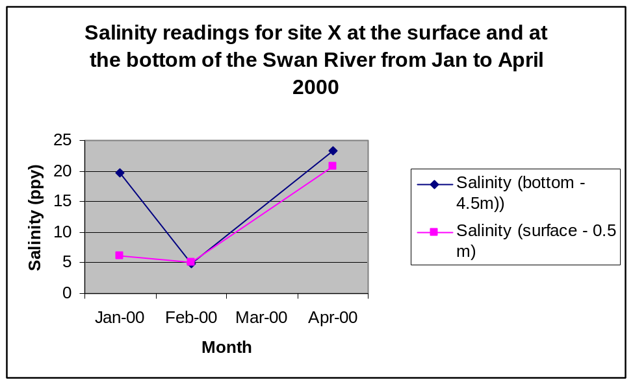

Description | Marks
correctly labelled axes  correctly scaled axes  points plotted accurately  depth identified using key/label | 1  1  1  1
Total | 4

Description | Marks
salt water moves upstream as a wedge  it sits below the freshwater due to higher density | 1  1
Total | 2

(i)

Description | Marks
large rain events cause freshwater to enter the system  dilution and mixing causes salinity to fall at the surface and at depth | 1  1
Total | 2

(ii)

Description | Marks
water flushed out to sea  salt wedge has moved up the river past this site  tidal exchange causes mixing of water/reduces stratification | 1  1  1
Total | 3

Description | Marks
important food source for other organisms  converts light energy to biomass/base of food pyramid/supports food web | 1  1
Total | 2

Description | Marks
lowered salinity favoured Microcystis  nutrient levels increased due to run-off from farms | 1  1
Total | 2

Description | Marks
long day length—availability of light for growth  warm temperatures/clear calm waters | 1  1
Total | 2

Description | Marks
determine extent of bloom and plan control/management measures  provide information to public regarding current status and health implications e.g. warnings not to swim in particular areas | 1  1
Total | 2

Description | Marks
Any one of the following:  - increase the salinity of the surface layer of the water beyond the tolerance of the algae  - mechanical removal of algae using a skimmer  - using flocculating material to try and sink the algae | 1
Total | 1

Question 6

Description | Marks
oxygen—animals respiration  temperature—lower oxygen levels/stress  conductivity—salinity osmotic gradient | 1  1  1
Total | 3

Description | Marks
recognise that 130 million litres is 17% of total  calculate 100%  divide by number of people (1.6 million)  correct answer = 478 litres per person per day | 1  1  1  1
Total | 4

Description | Marks
labelled diagram (semi-permeable membrane, compartments with concentrated and dilute solutions)  high pressure is applied to the compartment containing sea water  large amount of energy needed for pump which supplies pressure  compartments separated by a membrane with a very fine pore structure | 2  1  1  1
Total | 5

- (i)

Description | Marks
definition—process used to remove salt from salt water | 1
Total | 1

(ii)

Description | Marks
less rainfall—unable to fill dams  groundwater limited supply  desalination is non weather dependent | 1  1  1
Total | 3

Description | Marks
Any two:  map plant and animal species  identify endangered species and unique species  identify areas for seed collection  inform of appropriate revegetation | 1 mark each
Total | 2

(f)

Description | Marks
Any two:  plants would be suited to the local conditions/maintain soil stability  encourage native fauna back into the area  native animals would assist in pollination of plants  aesthetic/heritage value | 1 mark each
Total | 4

SECTION THREE

Description | Marks
For each point listed, one mark allocated. For each corresponding coherent explanation one mark allocated. | max 10 marks

Students may include any of the following points:

Description
In relation to the following points, discuss the effect on the reaction time and distance and how this relates to the stopping distance
- drink driving
- drug use
- fatigue
- distractions e.g. mobile phones, billboards, passengers

In relation to the following points, discuss the effect on braking distance and how this relates to stopping distance.
- speeding
- road conditions e.g. wet/slippery roads, gravel roads
- vehicle maintenance e.g. tyre condition, brakes

Description | Marks
For each point listed, one mark allocated. For each corresponding coherent explanation one mark allocated. | maximum 10 marks
.

Description
- describe Newton's First Law of Motion (inertia)
- when the car stops, an unrestrained occupant continues to move forward
- define momentum
- unrestrained occupant has greater momentum when hitting windscreen/dashboard
- seat belt slows down the forward movement due to the elasticity of the seat belt/less momentum
- seatbelt distributes the resultant force due to large surface area
- crumple zones take time to crumple
- slow the car and reduce the momentum
- not stopping instantly
- occupant in the car also has less momentum

.
Question 8

Students may include any of the following points. Each point should be well explained for a maximum of 2 marks per point.

Description | Marks
- most significant impact on reducing water consumption has been the introduction of the watering days regime  - using more water efficient plants in the garden  - different types of watering e.g. drippers rather than sprinklers  - education campaigns through advertising on TV and brochures included with water accounts  - Waterwise Rebate Program—cash back for water efficiency including wetting agents for gardens, approved front loader washing machines, water efficient shower heads,  - Waterwise Rebate Program –cash back for rainwater tanks to use water that would otherwise not be available  - reusing grey water for gardens using strict guidelines | maximum 8 marks
- underground water systems to reduce evaporation  - genetically modified plants to reduce need for water but maintain productivity  - changing to crops that do not require large amounts of water when it is not available | maximum 6 marks
- Australia dry continent/low freshwater supplies  - total annual rainfall decline 10% over past 30 years  - manage sources of water  - increase diversity of supply—dams, groundwater, desalination, recycling  - use of recycled water for purposes other than drinking so that drinking water supplies can be maintained  - conservation measures implemented to reduce need to increase supply | maximum  6 marks
Total | 20

Integrated Science: Sample Examination Stage 2
Mapping questions to content
Quest.  No | The practice of science |  | Conceptual understandings |  |  |  |  |  | The impact of science
 | 2A | 2B | 2A  Adolescents and driving | 2A Adolescents and music | 2B  Importance of water | 2B  Properties of water | 2B  Aquatic ecosystems | 2B  Water resources and sustainability | 2A | 2B
Section One—Multiple Choice
1 |  |  |  |  |  | ü
2 |  | ü
3 |  |  |  |  |  |  |  | ü
4 |  |  |  |  |  | ü
5 |  |  |  |  |  | ü
6 |  |  |  |  |  |  | ü
7 |  |  |  |  |  |  | ü
8 |  |  |  |  |  | ü
9 |  |  |  |  |  | ü
10 |  |  |  |  |  |  | ü
11 |  |  |  |  |  |  |  |  | ü
12 |  |  | ü
13 |  |  | ü
14 |  |  | ü
15 |  |  | ü
16 |  |  | ü
17 | ü
18 |  |  |  | ü
19 |  |  |  | ü
20 |  |  |  | ü

Quest.  No | The practice of science |  | Conceptual understandings |  |  |  |  |  | The impact of science
 | 2A | 2B | 2A  Adolescents and driving | 2A Adolescents and music | 2B  Importance of water | 2B  Properties of water | 2B  Aquatic ecosystems | 2B  Water resources and sustainability |  | 2A | 2B
Section Two—Short Answer
1 |  |  | ü |  |  |  |  |  |  | ü
2 | ü |  |  | ü |  |  |  |  |  | ü
3 |  |  |  | ü |  |  |  |  |  | ü
4 |  |  |  |  |  |  |  | ü |  |  | ü
5 |  | ü |  |  |  |  | ü |  |  |  | ü
6 |  |  |  |  |  | ü |  | ü |  |  | ü

Quest.  No | The practice of science |  | Conceptual understandings |  |  |  |  |  | The impact of science
 | 2A | 2B | 2A  Adolescents and driving | 2A Adolescents and music | 2B  Importance of water | 2B  Properties of water | 2B  Aquatic ecosystems | 2B  Water resources and sustainability |  | 2A | 2B
Section Three—Extended Answer
1 |  |  | ü |  |  |  |  |  |  | ü
2 |  |  |  |  |  |  |  | ü |  |  | ü

